DISTRICT CLUBS 2202
IGUALADA / VILAFRANCA PENEDES/
SANT CUGAT/ &-CLUB D2202
SUMMER CAMP 2017 - CATALONIA ART & NATURE
PLANNING OF ACTIVITIES
(Subjected to changes by the organization)
4TH JULY (Tuesday) ARRIVAL TO IGUALADA

• The Club will take care of picking up participants at El Prat Airport and transferring them to Les Moreres Tennis Club, where they can use the pool and bar / restaurant services. Dinner / reception in theTennis Club and collection of the participants by their families.

5TH JULY (Wednesday) BEACH DAY IN SITGES
• Visit the old town and "Museu Mar i Cel". In the afternoon visit the Monastery of Poblet.
• Picnic lunch. Dinner with the families.

6TH JULY (Thursday) DAY IN IGUALADA
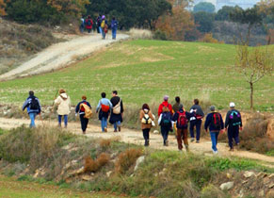

- Trekking in the morning. Visit an industrial company in the afternoon.
- Free time in Igualada’s old town
- Dinner at the rotary Club with assistance of the club members and host families.
7TH JULY (Friday) DAY IN BARCELONA
• Tourist route of modernist buildings.
• Free time and "Shopping" in the center of Barcelona.
• "Magic Fountains of Montjuic" show. Sandwiches and refreshments for dinner.
8TH JULY (Saturday) TRANSFER FROM IGUALADA TO VILAFRANCA DEL PENEDES
• Arrival at Vilafranca Tennis Club. Swimming pool, Padel, Tennis, Basketball, Squash, etc. Lunch at Club deTisis.
• At 8:30 p.m. participants will be greeted by the host families and dinner at the Rotary Club.
9TH JULY (Sunday) DAY IN VILAFRANCA AND COMARCA
• Bike ride through the vineyards of Penedés. Visit Bodegas Torres and lunch in a winery. In the afternoon stroll around the town, shopping and dinner with families.
10TH JULY (Monday)) DAY AT "PORT AVENTURA PARK"
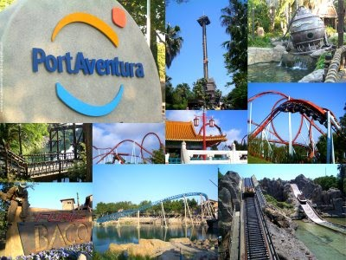
11TH JULY (Tuesday) BEACH DAY IN VILANOVA I LA GELTRU
• Vilanova i la Geltru beach, swimming and food. Barbecue dinner and farewell of the families.
12TH JULY (Wednesday) TRANSFER FROM VILAFRANCA PENEDES TO SANT CUGAT
• Day of arrival: accommodation and welcome dinner at the club.
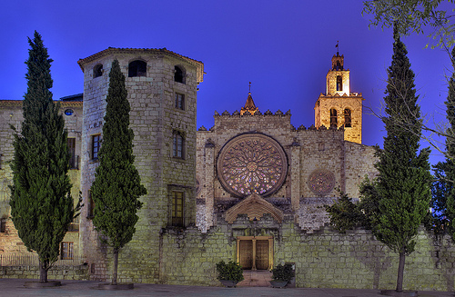
13TH JULY (Thursday): VISIT OF THE CITY OF SANT CUGAT
• City center, Monastery
• Industrial area (visit an important company)
• University area. (Business schools or faculty)
• Natural park area Collserola. (Hiking / trekking)
14TH JULY (Friday) – VISIT BARCELONA CITY
• Visit Tibidabo, Barça Museum, the city center: Passeig de Gràcia. Afternoon for shopping and dinner in a central place of Barcelona.
15TH JULY (Saturday) DAT AT EL GARRAF
• Excursion to El Garraf beach by train. Farewell dinner.

16TH JULY (Sunday) TRANSFER FROM SANT CUGAT TO E-CLUB D 2202
• Reception of the participants in the station of the Railway of the Generalitat.
• Families will accompany you to your residence to go to the Aeroclub Bages, where we will enjoy sea and mountain food.
• In the afternoon visit the city of Manresa with the families.

17TH JULY (Monday) DAY IN THE MOUNTAIN OF MONTSERRAT
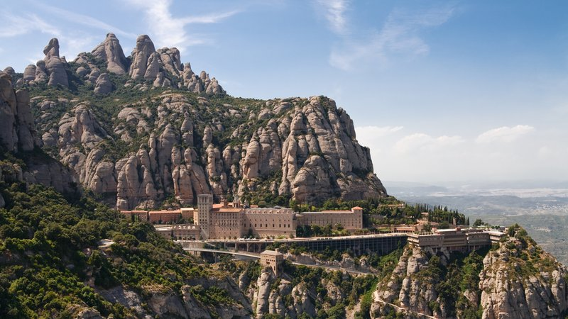
Day dedicated to stroll around Montserrat Mountain. Visit the Monastery and excursion through some of the different roads and hermitages. We will have lunch on the mountain.
• Dinner at the family's house, to go out for a refreshment at night.
18TH JULY (Tuesday) DAY OF L'OLLER DEL MAS
• Visit the Castle of l'Oller del Mas with tasting of the wine and the oil of the estate.
• Activities to choose: Paddle, Beach volley, Pitch & Putt, Swimming pool.
• Lunch will be at the Golf Restaurant
• Later we will accompany the young people to the houses to go out to dinner for snacks or to La Taverna del Pinxo.
19TH JULY (Wednesday) DAY IN CARDONA
• Visit the Museum of the salt mines of Cardona
• Visit the Castle of Cardona
• Lunch will be held in Cardona or in Manresa, depending on the time we set aside for the different visits and which will be more convenient for everyone.
• Return to the homes of families for shopping.
• At 21 hours we will celebrate the farewell dinner at Ramón Park Hotel de Santpedor.
20TH JULY (Thursday) ROTARY ECLUB D 2202 MANRESA TO AIRPORT

