ROTARY CLUB BARCELONA DIAGONAL
and
rotary CLUB tarragona tarraco augusta,
rotary club sitges, rotary club blanes

NAUTIC cruise camp “costa catalana”
COSTA DAURADA
COSTA BRAVA

REQUIREMENTS:

Participants: 10 Teenagers, 5 girls and 5 boys
Age: 16 / 17 years old
Price: 560 €

Dates: From the 1st to the 7th of July, 2018
Arrival: Barcelona
Farewell Point: Barcelona

Required documents: Parental permission, Medical Certificate, European Health Insurance Card, Health Insurance and Liability, document certifying that the teenager is able to swim, and introduction document from the sponsor Rotary Club (These docs will be forwarded to the applicants).

Programme.

Sunday, July 1: Arrival to the “El Prat T1/T2”, Barcelona Airport, ​​picking up the participants at arrival points.

Transfer to Port Olímpic and meeting of all young people.

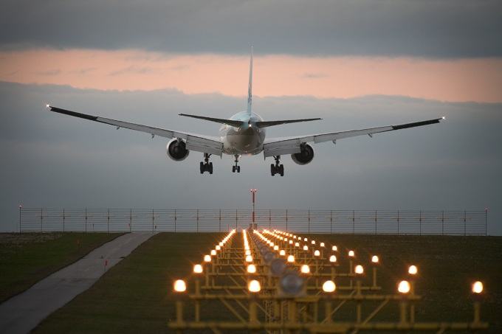

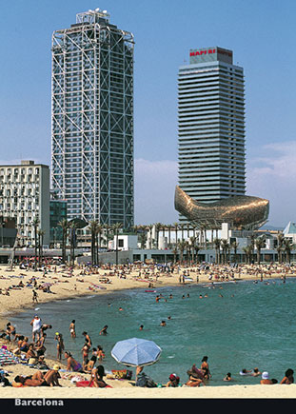

Dinner and overnight on the boat.
Sailing to Blanes (Costa Brava)

Monday, July 2: Blanes.

Recreational and touristic activities.

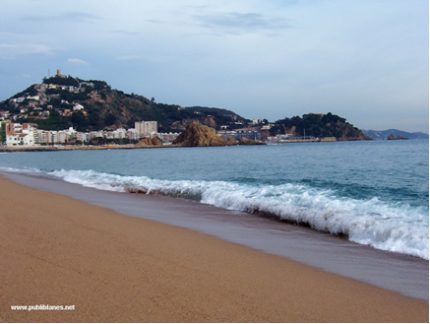

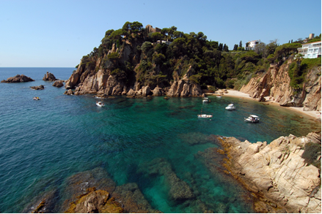
Lunch and dinner ashore.

Overnight on the boat. Sailing night to Sitges.

Tuesday, July 3: Sitges. Visiting Museum “Cau Ferrat” and “Palau Mar i Cel”.

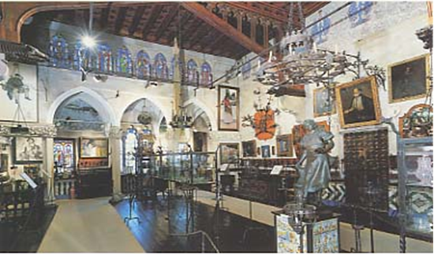

Touring participants round the area.

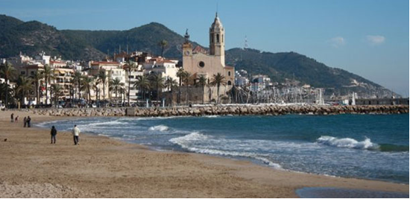

Lunch ashore.

Dinner on the boat.

Overnight on the boat. Sail to Tarragona.

Wednesday, July 4: Tarragona/Ametlla de Mar (Delta de l´Ebre).

Recreational and touristic activities.

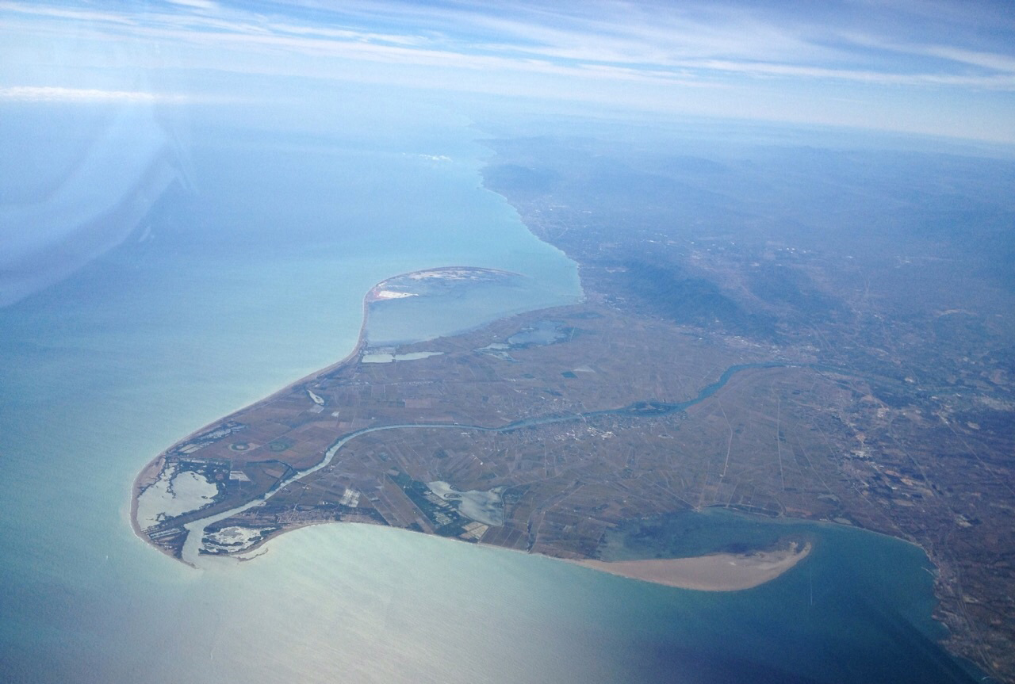

Visit Balfego Factory

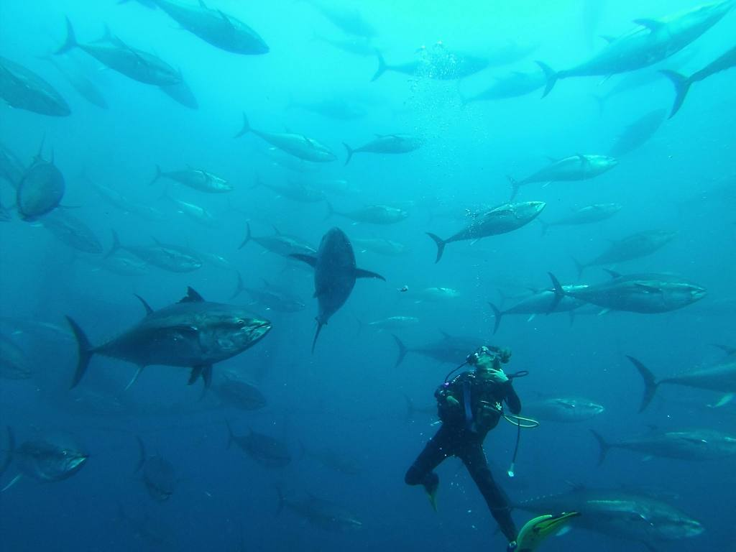

Lunch and dinner ashore.
Overnight on the boat.

Thursday, July 5: Tarragona.

Visit the old City and Tárraco Area.

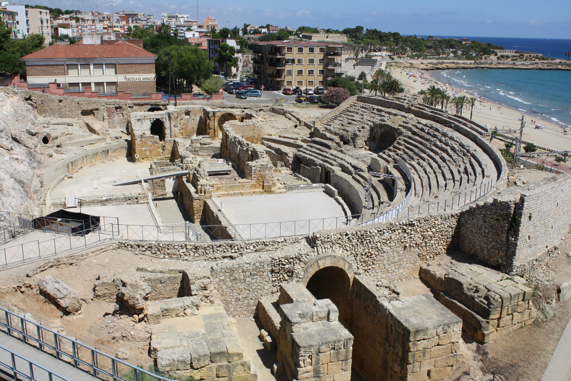

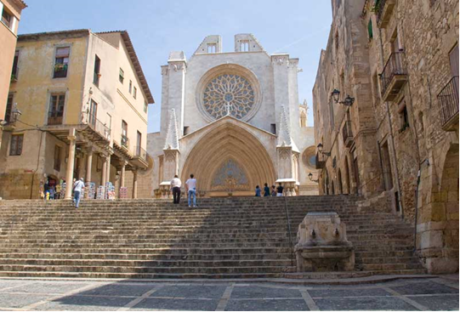

Lunch and dinner ashore.
Overnight on the boat. Sailing to Barcelona.

Friday, July 6: Barcelona Olímpic Marina.
Visiting “Sagrada Familia” and “Passeig de Gràcia” street in Barcelona.



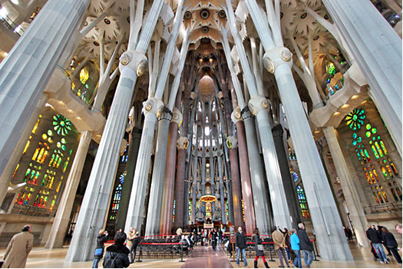

**The scales of navigation will depend on the climatology.
**Visits and timetable of the activities will depend on the availability.

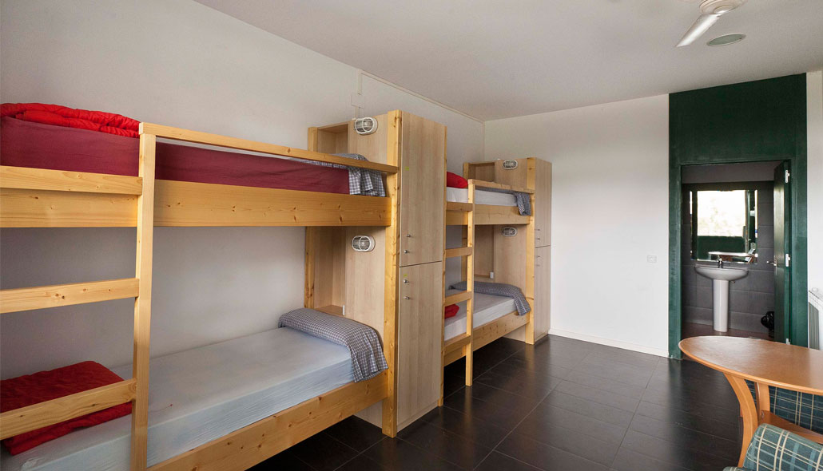

Farewell dinner with the attendance of Rotary Barcelona Diagonal Club members and families.
Overnight at the InOut Hostel (Vallvidrera-Barcelona).

Saturday July 7: Vallvidrera-Barcelona.

Transfers to departure points (El Prat T1/T2 Airport)



