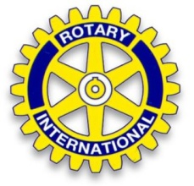 | Rotary International  District 1940 – Germany | 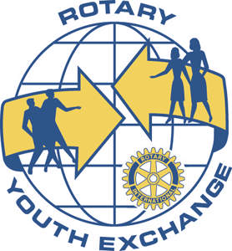

I N V I T A T I O N

International Summer Camp 2018
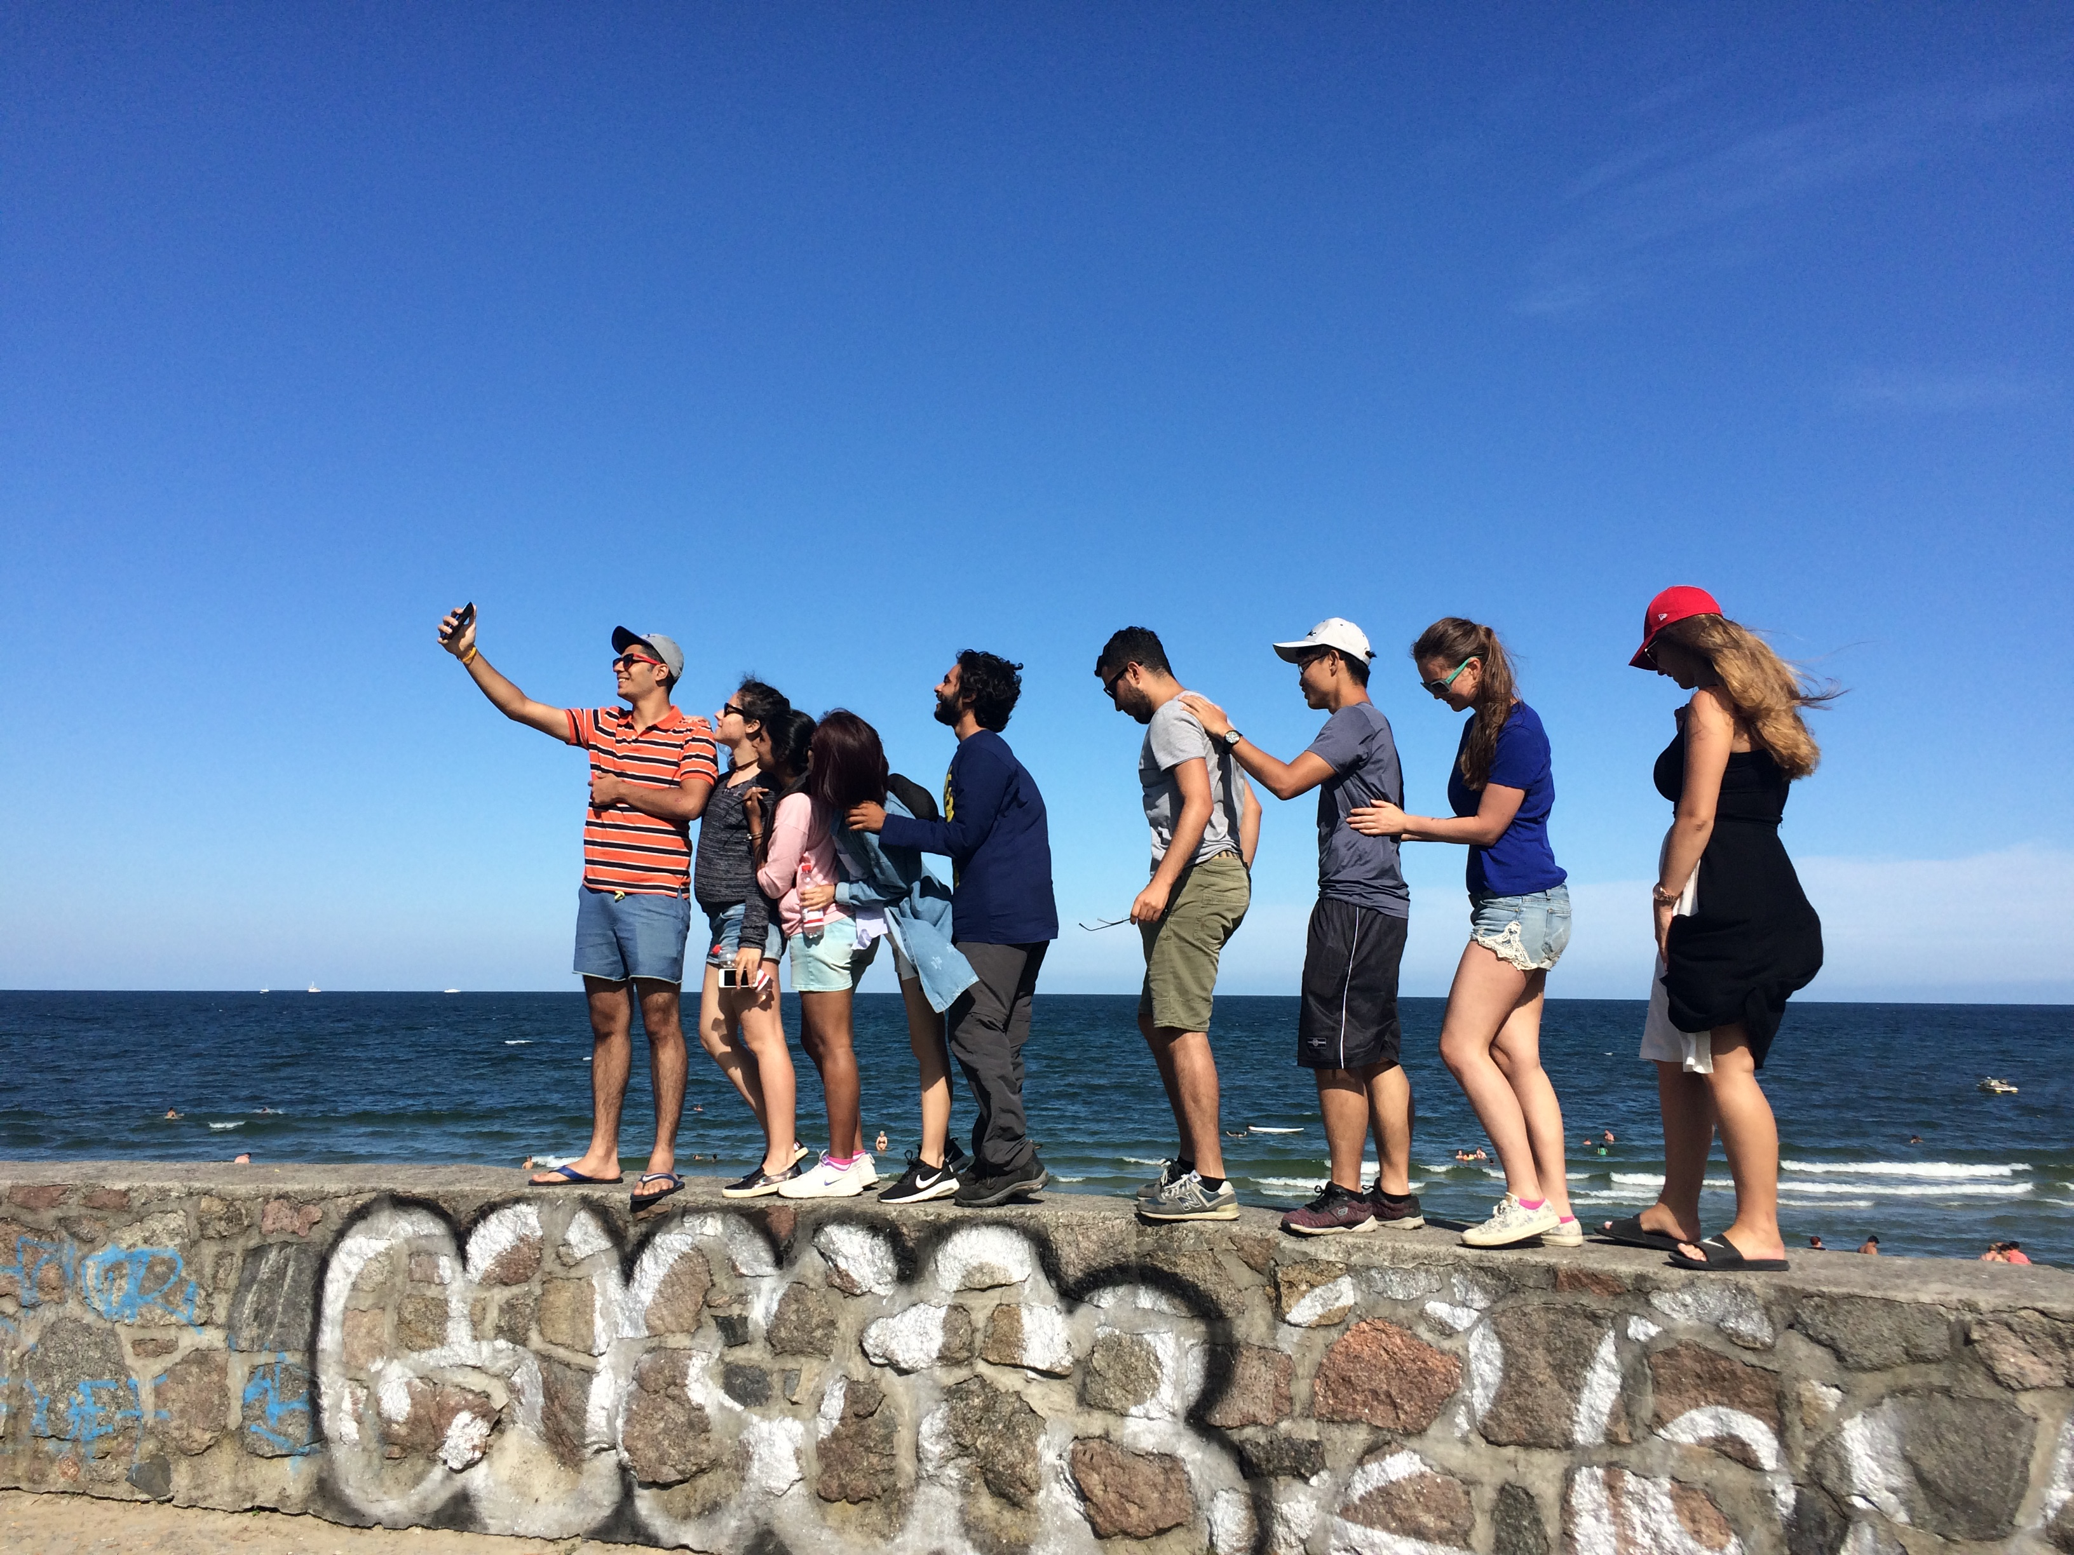
Camp theme | Discover Berlin, Brandenburg and the Baltic Sea
Dates | 09th August (arrival) to 26th August (departure) 2018
Hosting Rotary  District | District 1940 and its participating Rotary Clubs in the area of Berlin, Baltic Sea and the state of Brandenburg, Germany
Participants | 12 girls and boys (2 participants per country max.).
Age | 18 – 24 years  Acceptances will be granted on a “first come first served” basis subject to country and age requirements as above.
Language | Participants must have a good knowledge of English. German and other languages welcome. But camp language will be English!
Programme | During the camp the hosting Rotary Clubs will organize a varied and diverse programme, e.g. cultural, sports, sightseeing a.o. Be prepared to represent yourself and your country.
Accommodation | Accommodation will be in a youth hostel in Berlin near Alexanderplatz. 3 days will be spent at the Baltic Sea.
Clothing | Casual and formal. You need sports clothes, swimsuits and walking shoes.
Arrival/ Departure | by train: Berlin “Hauptbahnhof” (central railway station)  by plane: Berlin Schönefeld and Berlin Tegel  by bus: ZOB Berlin (central bus station)
Costs | Participants will have to pay a registration fee of 150 € after acceptance and travel costs to and from Berlin. They should also bring adequate pocket money. All other costs will be covered by the hosts.
Insurance | Participants must have sufficient health, accident, liability and luggage insurance.
Registration | The YEO´s of the participating country are asked to send their applications on international standard forms before 30th May 2018.  The application, with photos, should be sent to:  verenakeimer@yahoo.de
Apply to | Apply through your local Rotary Club / Rotary District.
Information | All participants will receive acceptance information as soon as possible, and final details about the camp will arrive no later than 31st July 2018.

